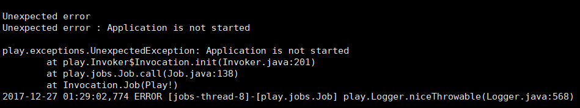

play.exceptions.UnexpectedException: Application is not started

分析：可能由于数据库连接数不够

show variables like 'max_connections';

show full PROCESSLIST;